District Suchitwa Mission, Idukki

**Best Practices to Manage COVID 19**

Name of Urban Local Body**: Thodupuzha Municipality**

**Title/ Category of Best Practice (some suggested categories include):**

* **Cleanliness/ sanitization of public places**

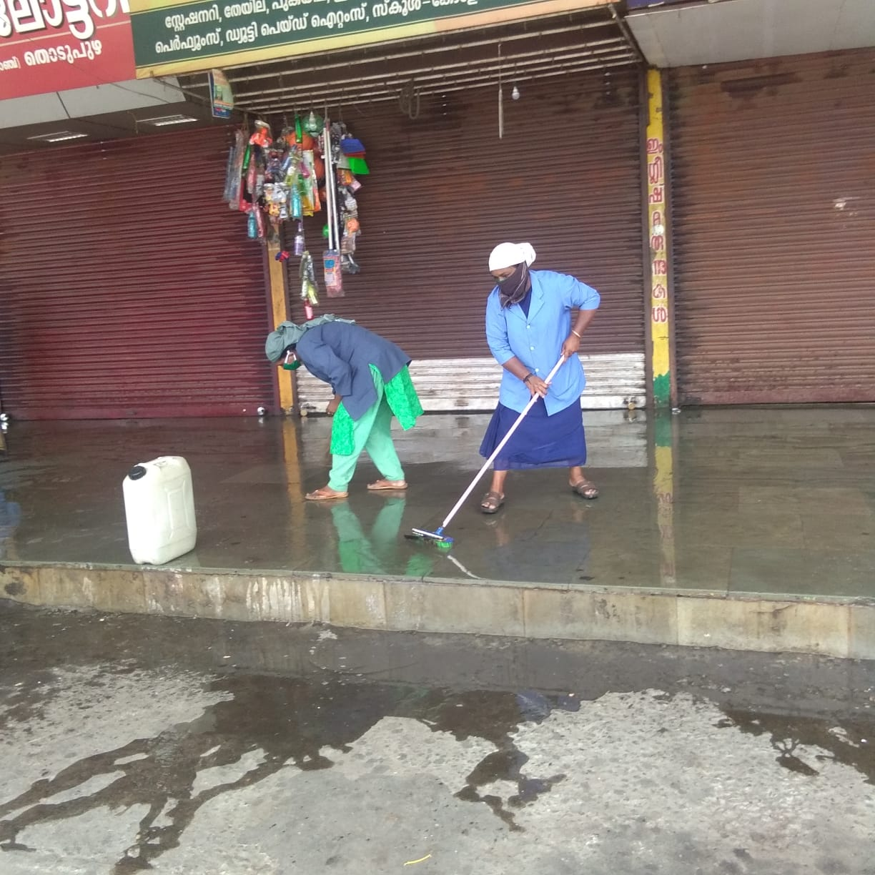

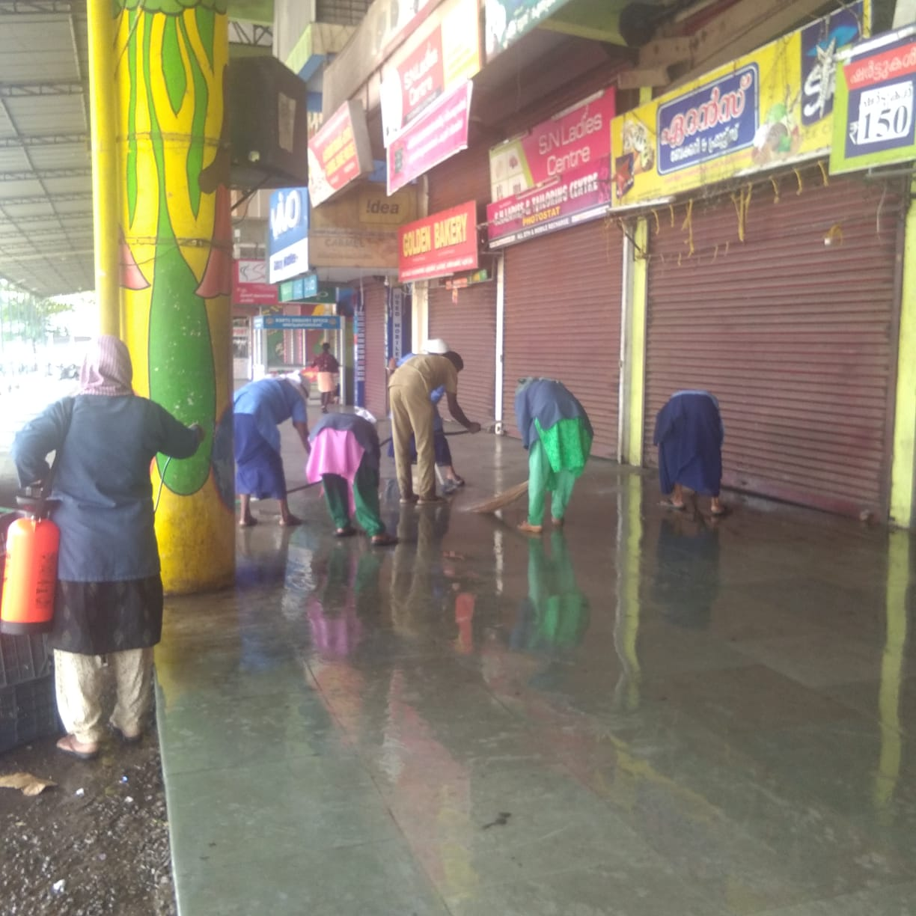

Cleaning activity at Municipal Bus stand thodupuzha

**Description of Initiative:**

* What are the key features of the initiative?

To clean all the public places in the municipality to avoid community spread of COVID 19

* Location/ region where initiative is being rolled out

Thodupuzha Municipality

* How many people have been involved?

16 nos.

* **Break the chain campaign**

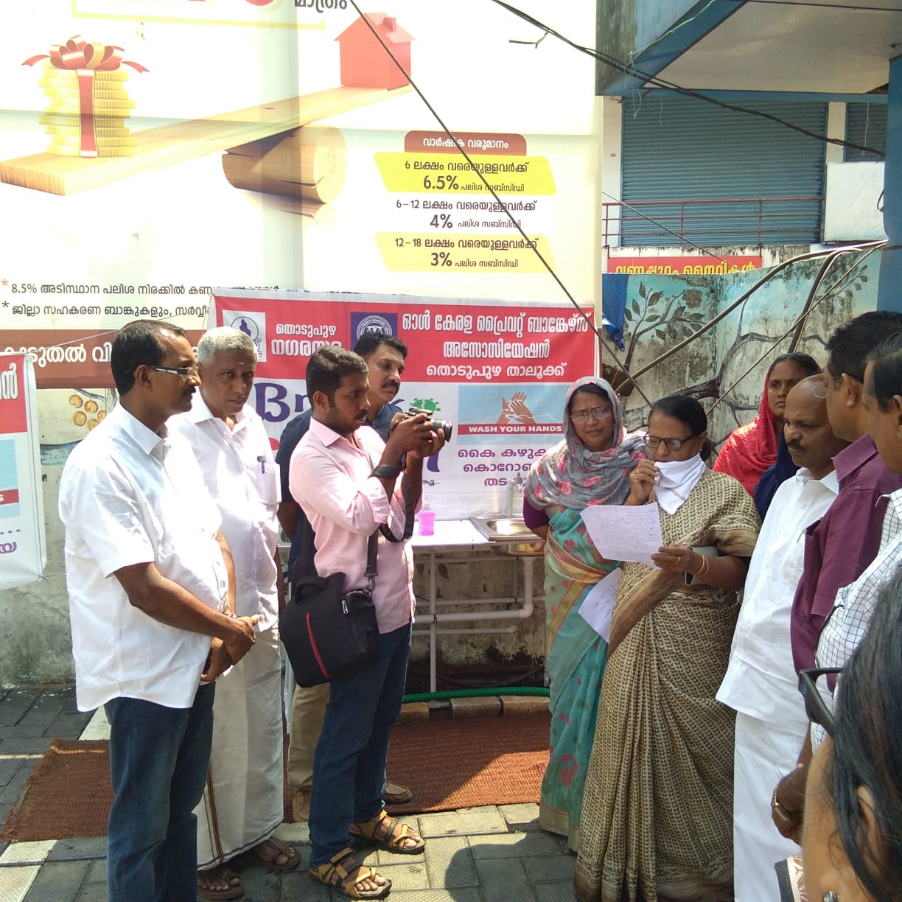

**Description of Initiative:**

* What are the key features of the initiative?

Awareness programme to public in the municipality to avoid community spread of COVID 19

* Location/ region where initiative is being rolled out

Thodupuzha Municipal area

* How many people have been involved?

120 nos.

* 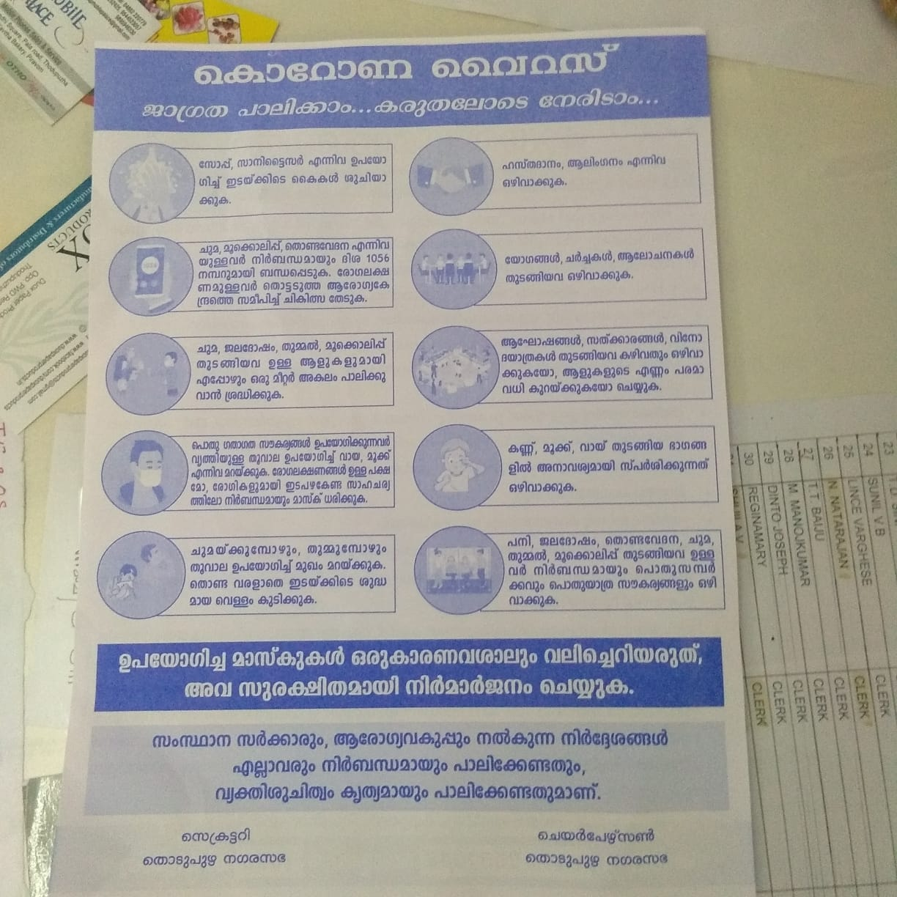**IEC campaign to spread awareness on COVID 19**

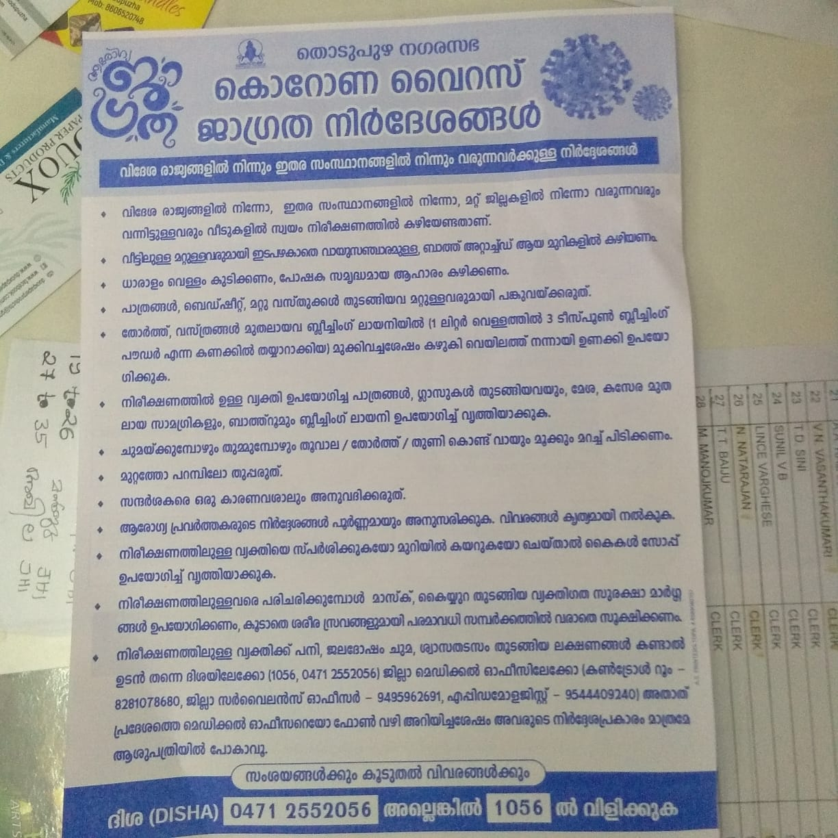

IEC poster at different places, thodupuzha Municipality

**Description of Initiative:**

* What are the key features of the initiative?

Awareness programme to public in the municipality to avoid community spread of COVID 19

* Location/ region where initiative is being rolled out

Thodupuzha Municipal area

* How many people have been involved?

80 nos